

**COMPUTER SCIENCE PROJECT**

**Session: 2025-2026**

**A Project Report On “Employ Management System”.**

Submitted by: Guided by:

Rudra Karia and Pabitra Jena Mrs. Bhavnita Postaria

Class XII (science A) (PGT Computer Science)

**CONTENTS**

|  |  |  |
| --- | --- | --- |
| Sr.no. | Name of topic | Pg.no. |
| 1. | CERTIFICATE | 03 |
| 2. | ACKNOWLEDGEMENT | 04 |
| 3. | INTRODUCTION | 05-06 |
| 4. | PYTHON OVERVIEW | 07 |
| 5. | FEATURE OF PYTHON | 08 |
| 6. | ADVANTAGE OF PYTHON | 08 |
| 7. | STEPS TO DOWNLOAD PYTHON | 08 |
| 8. | ABOUT MYSQL | 09 |
| 9. | STEPS TO DOWNLOAD MYSQL | 11 |
| 10. | ADVANTAGES OF EMPLOY MANAGEMENT SYSTEM | 11 |
| 11. | OBJECTIVE OF THE PROJECT | 12 |
| 12. | PROPOSED SYSTEM | 12-13 |
| 13. |  |  |

**Certificate**

This is to certify that **Rudra Karia** and **Pabitra Jena** students of **Class 12**th have successfully completed their project report for project entitled **“EMPLOY MANAGEMENT SYSTEM”** in the subject of **Computer Science** for the academic session 2025–2026.

Under the esteemed guidance and mentorship of

**Mrs. Bhavnita Postaria**. The report is the result of his efforts and endeavours. The report is found worthy of acceptance as final Project report for the subject Computer Science of class XII (Science).

Signature of Internal Examiner Signature of external Examiner

Signature of principal

**Acknowledgement**

we take this opportunity to express our heartfelt gratitude to our project guide, Mrs. Bhavnita Postaria, for her invaluable guidance, constant encouragement, and constructive feedback throughout the course of this project. Her support and keen interest in our work have been instrumental in the successful completion of this project.

We are also deeply thankful to Mrs. Lincy Pancholi, our respected Principal, for her support and for providing all the necessary resources and facilities required to carry out this project effectively.

We also extend our sincere thanks to our classmates and friends for their timely help, suggestions, and encouragement during the course of the project.

Last but not least, we would like to express our profound gratitude to everyone who, directly or indirectly, contributed towards the successful completion of this project.

**INTRODUCTION**

The Employee Management System is a fundamental project designed to handle the administrative tasks related to employee information in an organization. It is a simple, yet very powerful way to systematically and programmatically manage employee data. Employee data has always been an essential function in any organization, regardless if it is done by hand, by manual entry, or on a spreadsheet or digital platform. The idea of record keeping for employees can be traced back to the inception of early empires. In ancient times, businesses and government offices had record books of written logs for employees, as well as the work that they performed. Today, all aspects of employee record keeping have become even more easy with computers.  Computerization has provided precise and effortless ways of acquiring what is needed to manage employee records; the employee management system is now faster, more reliable and is much easier to manage rather than struggling with paper records.

An employee management system has functionality for the addition of employees, and updating records, as well as deleting records, and searching for employee records. Employee management systems typically make the necessary details of identifying employees and management of their essential records. Employee management systems typically manage an employee's employee id, employee name, employee age, employee job title, employee department, employee salary and employee contact. As organizations use this tool to supply accurate and dependable records, they have and will continue to reduce human error and the comfort that data was processed in a more precise manner will promote trust and confidence. Similarly, this tool saves a considerable amount of time and is ultimately easier to keep record of an employ.

While the concept is simple, designing and implementing of an agreeable employee management system requires adequate planning, data organization and coding. For example, the student programmer or user can appreciate and experience how important data management, selection of data structures, handling of files, designing user interfaces, and controlling the logical flow of the user is essential. The redesigned programmer or user has been engaged in an essential aspect of the software development life cycle.

Additionally, a system like this encourages the development of important skills such as database storage, data entry validation, and error detection and correction. It also leads us to critically think about data relationships, security and user experience that are important in real-world software solutions.

Employee Management Systems optimize not only organizational efficiencies but also contribute to more efficient planning and decision making with regard to human resources. Whether applied in a small business, an educational institution, or a multinational corporation. Employee management systems can significantly optimize Human Resource and impact employee workflow throughout the organization.

In the last few years, the evolution towards digital and automated employee management systems has begun to incorporate processing and storage through web-based portals, cloud storage and mobile applications. The real benefits of using such systems, such as the ability for real-time updates, more efficiency in correction of employee data and the convenience of accessing data anywhere, are some advantages of employee management systems. Though these systems developed in python set the groundwork for learning all of the mechanisms in these more complicated systems by learning all of the underlying principles first.

An Employee Management System is an essential and is a relevant project that illustrates the importance of organized data management and systematic planning. It's an excellent case study of how technology allows us to satisfy multiple complicated tasks and help us to be more productive.

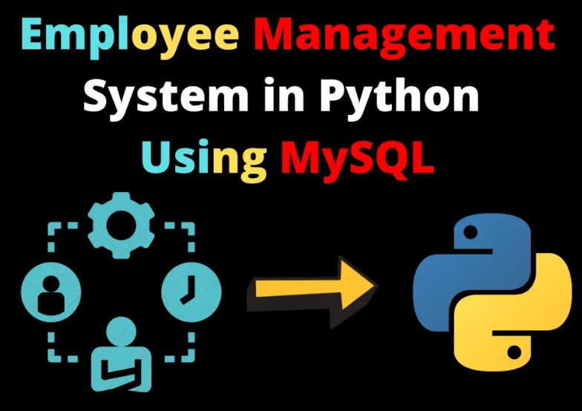

**Python overview**

Python is a general-purpose high-level programming language. It is an open-source language, released under a GPL-Compatible license. Python Software Foundation (PSF), a non-profit organization, holds the copy-right of python. Guido Van Rossum conceived python in the late 1980s. It was released in 1991.

Python has gained huge popularity in a wide variety of industrial and academic applications. This programming language has an easy to learn and English-like syntax allowing programmers to write fewer lines of code and achieve more functionality.

Python allows for multiple programming methods allowing the programmer to select the style that fits the end project best. Python is used for web development, data analysis, artificial intelligence, machine learning, automation, networking, game development and scientific computing.

The Python Package Index (PYPI) has thousands of libraries that make Python stronger. Developers can add features quickly without making everything from zero. Python works on different systems like Windows, macOS, and Linux without many changes. This makes it easy to move and use programs anywhere.

The vast network of Python developers contributes to continually enhancing Python, detailed documentation, and a number of online resources, tutorials, and forums. Because of this active community it is easy to find help in problem-solving and learning becomes simpler. Many big companies like Google, NASA, Netflix, and Facebook use Python because it is reliable and helps build things quickly. Python is great for creating and testing ideas fast. Because of these strengths, Python was chosen to build the Employee Management System.

The work identified in this project illustrated programmers can build valuable, efficient, and scalable solutions in the future using Python, it helps them to get deeper understanding of the programmatic knowledge they acquired.

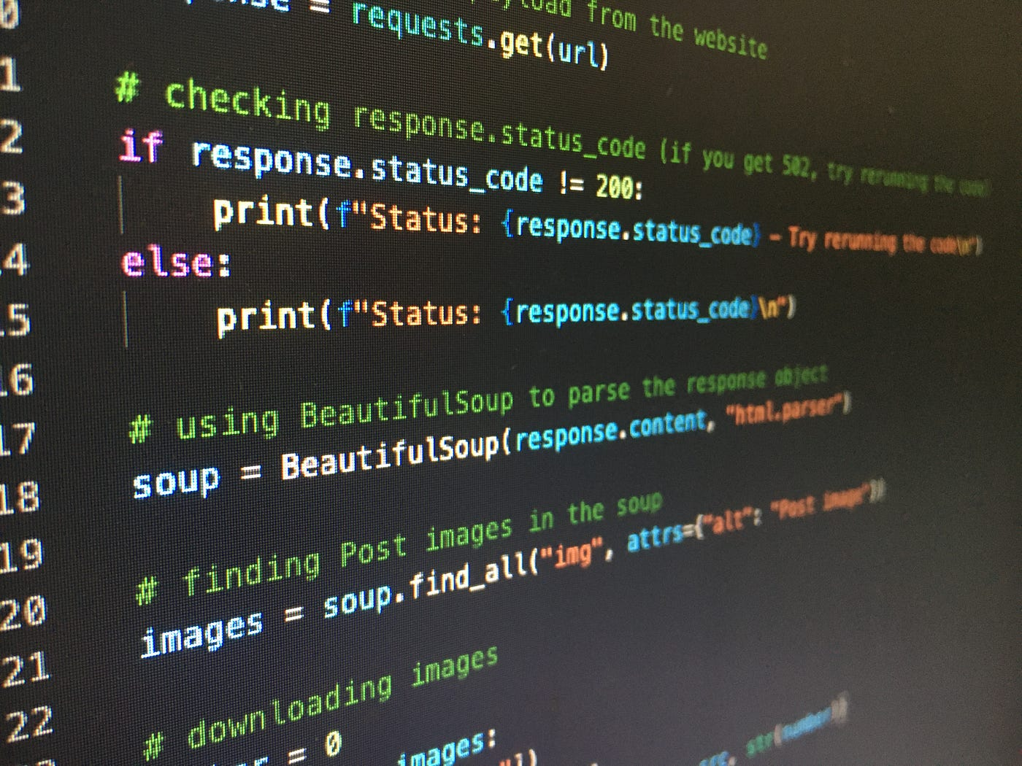

**Features of python:**

1. **Easy:**  Python is a very easy to learn and understand.
2. **Interpreted:** It is interpreted (executed) line by line. This makes it easy to test and debug.
3. **Object** **Oriented:** The python programming language supports classes and objects.
4. **Free and Open-Source:** The language and its source code are available to the public for free.
5. **Portable**: Since it is open source, we can run python on windows, mac, Linux, or any other platforms.
6. **GUI (Graphical User Interface) programming:** We can use it to develop a GUI.
7. **Large Library:** Python provides us with a large standard library. We can use it to implement a variety of functions.

***Advantages of Python-***

* 1. Extensible
  2. Portable

## Free & Open-Source

## Readable

## Embeddable

## Improved Productivity

## Simple and Easy

**STEPS TO DOWNLOAD Python: -**

1. Point your web browser to the download page on the Python website [(www.python.org)](http://www.python.org/).
2. Select the latest Windows x86 MSI Installer and click on the link to download the .msi installer.
3. Run the installer.
4. Select “Install for all users” and click the Next > button.
5. Keep the default option (C:\Python32\) as the destination directory and click Next again.
6. Don’t make any changes in the “Customize Python 3.2.3” dialog, just click Next again.
7. Click Yes if asked if this program should be allowed to install software on your system.
8. Click the Finish button when installation completes.

**ABOUT MYSQL:**

MYSQL is a widely-used open-source relational database management system (RDBMS). Which stores, edits and retrieves data for any existing implementation. MYSQL is based on SQL (Structured Query Language), which is a query language. MYSQL is mainly owned by Oracle Corporation. MYSQL is known for its speed and user-friendly design.

This has a great impact for an employee management system. For example, the employee management system will be tracking employee data (e.g., employee names, employee designations, employee salaries or payroll, employee attendance, employee contact data, etc.). The data will safely store in a table structure and will be retrievable when the queries are executed. Utilization of MYSQL makes relationship space for overnight multiple records go hand-and-hand.

Due to MYSQL support for multi-user, we do not need to worry about a single user interacting with a single MYSQL implementation while at the same time someone else is using the same table without an immediate concern for data loss.

Honest and accurate employee data handling must be the focus because employee management system implementation will be providing insights throughout the organisation.

MYSQL is simply robust to the organization and improvement to the implementation of employee data accurately and efficiently!

**steps to install MYSQL on Windows**:

**Step 1:** Go to the official Our MYSQL website: [https://dev.oursql.com/downloads/installer/](https://dev.mysql.com/downloads/installer/).Choose **"Our MYSQL Installer for Windows”.**

**Step 2:** Run the Installer.

**Step 3:** Choose Setup Type (Recommended: Choose Developer Default). Click Next.

**Step 4:** Check for Requirements. If needed, it will download and install them.  
Click Execute to install.

**Step 5:** Click Execute to install MYSQL and related tools. Wait for installation to complete.

**Step 6:** MYSQL Server Configuration**.** Select Standalone MYSQL Server. Set a root password and add a user (optional but useful).

**Step 7:** Finish Setup**.** Once configuration completes, click Finish.

**Step 8:** Verify Installation

1. Open Our MySQL Workbench.
2. Connect to the Our MYSQL server using:
   * **Host**: localhost
   * **Port**: 3306
   * **User**: root
   * **Password**: Your root password

**Advantages of employ management system:-**

* Stores all employee information (personal, professional, salary, etc.) in one place.
* Easy to access, update, and manage data.
* Reduces manual paperwork and errors.
* Can handle increasing number of employees as the organization grows.
* Easy to upgrade and add more features (e.g., performance tracking, document uploads).
* Reduces HR operation costs by minimizing manual tasks.
* Open-source technologies like Python and MySQL further cut down development expenses.
* Useful for audits and planning.
* Excellent for students or beginners to understand Real-world project structure.

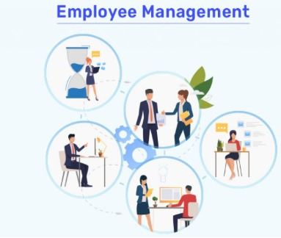

**Objective of the project:-**

1. To maintain a centralized database of employee information.
2. To provide secure access to employee data.
3. To improve data accuracy and consistency.
4. To reduce human error.
5. To enable quick decision-making through real-time reports and analytics.

## **Proposed System: -**

The presented Employee Management System is a digital platform or tool to automate and improve many functions of human resources work, such as, employee information recordkeeping, attendance tracking, leave management and salary reports. The system will be based on an architecture that uses Python for the backend logic and MySQL for the database, and is based on one platform that can store information about all the employees in an efficient way. Recordkeeping will not need to be undertaken manually, therefore errors in terms of producing incorrect or inconsistent records will be reduced, each situation will not take any longer that it must and all HR people’s valuable time can be better-managed. Contained in the system will be features like a secure login, a role-based access-controlled system, easy-to-use interfaces for administrators and employees so they can obtain accurate information and make contact with the appropriate HR personnel if they are required to.



Employees will be able to see and maintain real-time access for daily HR operations and HR reporting, rather the HR department will be able to view a true and current reporting for the HR function. Therefore, management will have undoubtably accurate data to enable them to make informed decisions faster. The management and reporting feature will reduce some errors related to data, increase employee productivity by less time wasted checking and not managing data and produce transparency to amount of business value being process for the organisation and their employees. The proposed Employee Management System being presented has great scalability, be user friendly and cost-effective development for those organisations in education, any business or institution managing a workforce.

